Fish Passage Plan (FPP) Change Request Form
Change Form # & Title: 16TDA001 – Adult Ladder Crowding
Date Submitted: November 20, 2015
Project: TDA
Requester Name, Agency: FPOM Adult Ladder Crowding Task Group
Final Action:
FPP Section: TDA section 2.5.2. Adult Fish Facilities Operating Criteria - Fish Passage Season (March 1 – November 30).
Justification for Change: See memo from FPOM Task Group on following pages.
Proposed Change: Add new section:
2.5.2.13. Ladder Crowding. Project personnel should assess the ladder crowding situation daily during the peak seasonal passage periods, when daily East Fishway passage count exceeds 25,000 (20,000 if ladder temperatures are above 70F) combined salmonids per day. The following guidance will apply:
- Inspectors shall walk entire East Fishway ladder, exit to east entrance, twice daily. Observations and picture recording will be made at the pool between 157 and 158, the pool downstream of count station, and the pool at the 180° bend in the ladder.
- During East Fishway passage exceeding 35,000 (30,000 if ladder temperatures are above 70F) combined salmonids per day, if the project biologists identify a fish crowding emergency or if any mortality is observed anywhere in the fishway, implement an emergency spill operation (currently 15 kcfs, 6k (4 stops) from bay 1 and 4.5 k (3 stops) each from bays 7 and 8), in an attempt to alleviate crowding. This operation would continue as long as the fish passage numbers are at or higher than the project passage (both ladders) occurring when the operation started or unless otherwise determined by FPOM.
- If inspectors see a crowding situation that is not an emergency but is cause for concern, FPOM will be consulted to evaluate the situation. If the team determines the crowding situation is severe enough, the spill operation will be implemented as mentioned in #2 above.

Comments from others:

Record of Final Action:
November 20, 2015
FILE MEMORANDUM

FROM: FPOM task group

SUBJECT: Suggested Fish Passage Plan (FPP) Language for The Dalles Ladders Adult Fish Crowding

Background: The subject issue has been discussed since the 2013 fall passage season when we experienced large numbers of fall Chinook passing through the lower Columbia River in general and The Dalles Dam in particular. A very limited spill test (three kcfs, several hours) was tried at that project. See file memos in November 2013 and April 2014 FPOM documents for more information on the crowding issue and that spill test. During 2014, an FPOM task group worked to determine project operational changes that might help alleviate the ladder crowding issue if it were to occur again. The primary purpose of such an operation would be to distribute some of the project passage to the less used north ladder.

An operation (spill pattern and amount) was determined during an August 25-28, 2014, work trip to the Corps’ Engineer Research Development Center, Coastal and Hydraulics Laboratory in Vicksburg, Mississippi. As a result of that work, it was agreed to try a limited duration spill test during the 2014 fall Chinook run. This test consisted of a spill volume of 15 kcfs and two spill patterns, and ran from September 9-15, 2014 (see memo files from the October 2014 FPOM meeting for ladder count results).

During the period of this spill test there was also an ongoing adult radio tracking study and one of its goals was to further investigate the crowding issue at this project. A letter report from the University of Idaho dated September 24, 2015, summarized the findings of that portion of the study. The study basically corroborated the window count observations that showed that fish (in this case steelhead) did appear to respond to the attraction spill with increased approach and passage through the north ladder. The study failed to show that steelhead passage was delayed by the crowding in the east ladder in 2014. It also suggested that the spill scenario used in September 2014, may have caused moderate delay in steelhead entrance and passage through the north fishway. This study does not, however, specifically address Chinook passage time which may be different than steelhead, particularly given the spawning season differences and it does not assess other damages, both direct and indirect, that may occur to fish as a result of the crowding situation.

Since that test in 2014, the FPOM and the task group have discussed the next steps a few times, however, there has been no agreement on specific language for a FPP change form regarding this issue. In most cases, the discussion has broken down because we have no specific crowding criteria for a ladder like the East Ladder at The Dalles. Another issue has been the lack of a specific biological consequence due to overcrowding in the ladder. Nevertheless, some regional biologists continue to believe that The Dalles Dam could have a ladder capacity issue in the future and that some remedial action guidance should be included in the FPP.

Proposal: To resolve this issue, the following is recommended language for inclusion to the 2016 FPP.

Project personnel should assess the ladder crowding situation daily during the peak seasonal passage periods, when daily passage exceeds 20,000 chinook per day. The following guidance will apply:
- During Chinook passage exceeding 20,000 per day, inspectors shall walk entire fishway ladder, exit to east entrance twice daily. Observations and picture recording will be made at pool between 157 and 158, pool downstream of count station and pool at 180 degree bend in ladder.
- During Chinook passage exceeding 25,000 per day, if any mortality is observed anywhere in the fishway, implement an emergency spill operation (currently 15 kcfs, 6k (4 stops) from bay 1 and 4.5 k (3 stops) each from bays 7 and 8), in an attempt to alleviate that crowding. This operation would continue as long as the fish passage numbers are at or higher than the project passage numbers that started the operation.
- During Chinook passage exceeding 30, 000 per day, FPOM will be consulted daily to evaluate crowding conditions within fishway and comparing with previous observations and pictures. If the team determines the crowding situation is severe enough, the spill operation will be implemented as mentioned in #1 above.

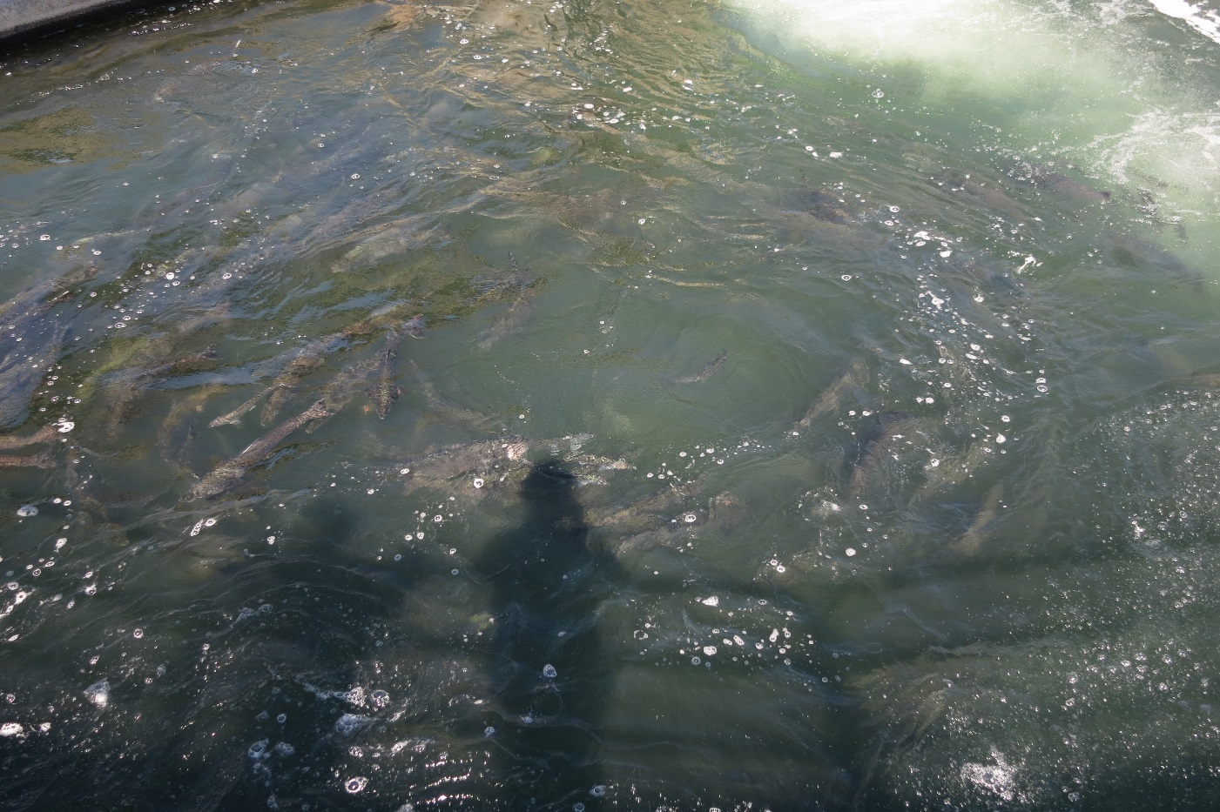
Figure 1. Example of a crowded ladder – the turning pool at The Dalles Dam East Ladder, 9-11-2013 (26,000 total fish East Ladder count that day).

